*Laboratory Report*

**INTERNET TECHNOLOGIES LAB.**

**CAP5004L**

**School of Engineering**

**Department of Computer Science and Engineering**

|  |  |
| --- | --- |
| **Submitted By** | |
| **Student Name** | Amit |
| **Roll Number** | 180020307001 |
| **Section/Group** |  |
| **Department** | Computer Science and Engineering |
| **Session/Semester** | 2020-21/ Odd Semester |
| **Submitted To** | |
| **Faculty Name** | Ms. Manka Sharma |



**GD Goenka University**

Sohna road, Gurugram, Haryana

**Table of Content**

|  |  |  |  |
| --- | --- | --- | --- |
| Sl No | Date | Aim of the Experiment | Signature/date |
|  |  |  |  |
|  |  |  |  |
|  |  |  |  |
|  |  |  |  |
|  |  |  |  |
|  |  |  |  |
|  |  |  |  |
|  |  |  |  |
|  |  |  |  |
|  |  |  |  |

|  |  |  |
| --- | --- | --- |
| **Experiment No-8.1** |  | **Date:** |

**Aim of the Experiment:**

Write a JavaScript program to list the properties of a JavaScript object.

Sample object:

var student = {

name : "David Rayy",

sclass : "VI",

rollno : 12 };

**Source Code**

<!DOCTYPE html>

<html lang="en">

<head>

<meta charset="UTF-8">

<meta name="viewport" content="width=device-width, initial-scale=1.0">

<title>Document</title>

</head>

<body>

<ul id="data"></ul>

<script>

var student = {

name : "David Rayy",

sclass : "VI",

rollno : 12

};

var ul = document.getElementById('data');

ul.innerHTML += `<li>Name: ${student.name}</li>`;

ul.innerHTML += `<li>Student Class: ${student.sclass}</li>`;

ul.innerHTML += `<li>Roll No: ${student.rollno}</li>`;

</script>

</body>

</html>

**Output**

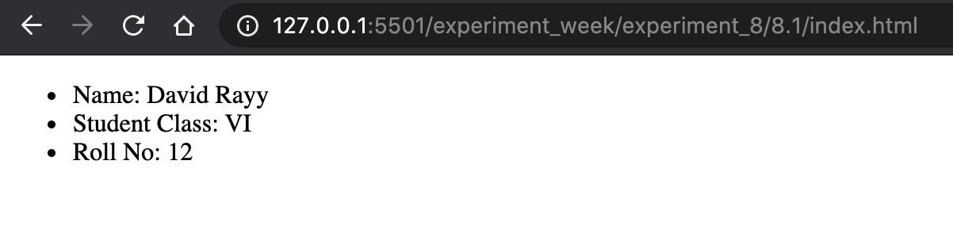

|  |  |  |
| --- | --- | --- |
| **Experiment No-8.2** |  | **Date:** |

**Aim of the Experiment:**

Write a JavaScript program to delete the rollno property from the following object. Also print the object before or after deleting the property.

Sample object:

var student = {

name : "David Rayy",

sclass : "VI",

rollno : 12 };

**Source Code**

<!DOCTYPE html>

<html lang="en">

<head>

<meta charset="UTF-8">

<meta name="viewport" content="width=device-width, initial-scale=1.0">

<title>Document</title>

</head>

<body>

<ul id="data"></ul>

<script>

var student = {

name : "David Rayy",

sclass : "VI",

rollno : 12

};

delete student.sclass;

var ul = document.getElementById('data');

ul.innerHTML += `<li>Name: ${student.name}</li>`;

ul.innerHTML += `<li>Student Class: ${student.sclass}</li>`;

ul.innerHTML += `<li>Roll No: ${student.rollno}</li>`;

</script>

</body>

</html>

**Output**

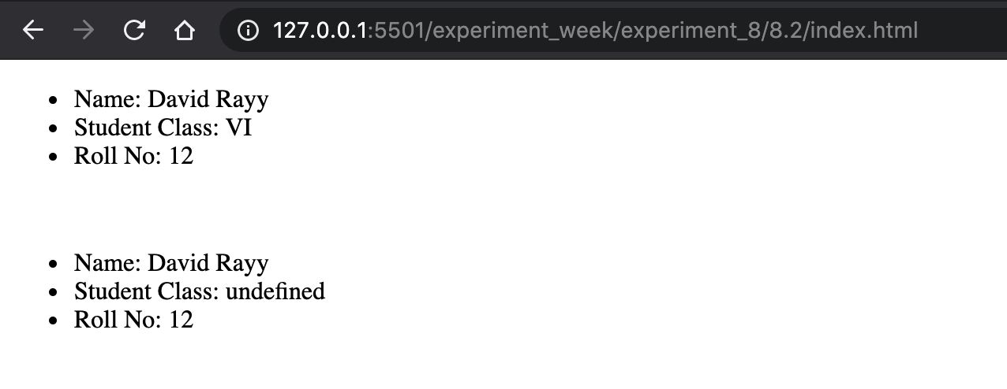

|  |  |  |
| --- | --- | --- |
| **Experiment No-8.3** |  | **Date:** |

**Aim of the Experiment:**

Write a JavaScript program to add the emailId property to the following object. Also print the object before or after adding the property.

Sample object:

var student = {

name : "David Rayy",

sclass : "VI",

rollno : 12 };

**Source Code**

<!DOCTYPE html>

<html lang="en">

<head>

<meta charset="UTF-8">

<meta name="viewport" content="width=device-width, initial-scale=1.0">

<title>Document</title>

</head>

<body>

<ul id="data1"></ul> <br>

<ul id="data2"></ul>

<script>

var student = {

name : "David Rayy",

sclass : "VI",

rollno : 12

};

var ul = document.getElementById('data1');

ul.innerHTML += `<li>Name: ${student.name}</li>`;

ul.innerHTML += `<li>Student Class: ${student.sclass}</li>`;

ul.innerHTML += `<li>Roll No: ${student.rollno}</li>`;

ul.innerHTML += `<li>Email: ${student.email}</li>`;

student.email = "amitdagar4096@gmail.com";

ul = document.getElementById('data2');

ul.innerHTML += `<li>Name: ${student.name}</li>`;

ul.innerHTML += `<li>Student Class: ${student.sclass}</li>`;

ul.innerHTML += `<li>Roll No: ${student.rollno}</li>`;

ul.innerHTML += `<li>Email: ${student.email}</li>`;

</script>

</body>

</html>

**Output**

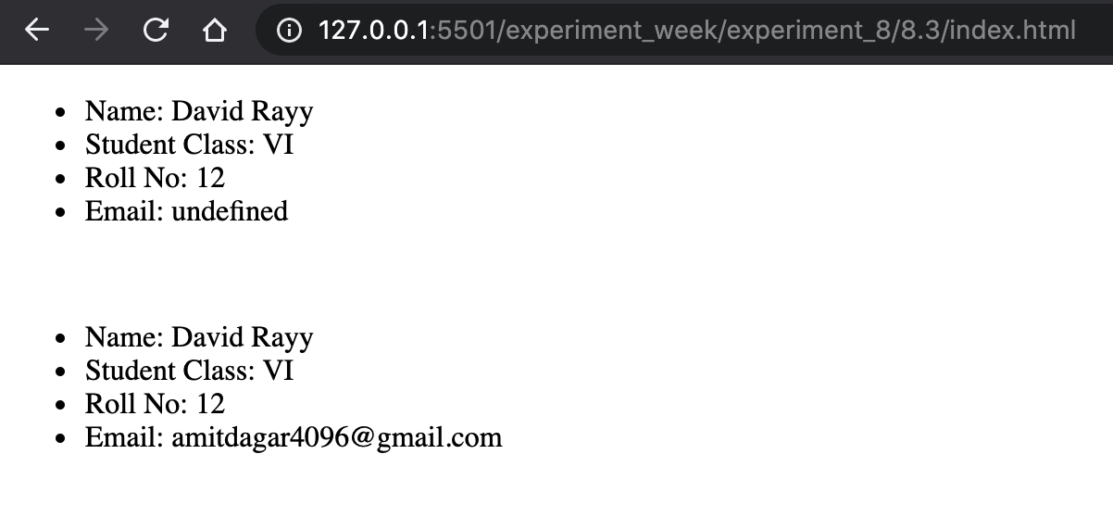

|  |  |  |
| --- | --- | --- |
| **Experiment No-8.4** |  | **Date:** |

**Aim of the Experiment:**

Write a JavaScript program to get the length of a JavaScript object.

Sample object :

var student = {

name : "David Rayy",

sclass : "VI",

rollno : 12 };

**Source Code**

<!DOCTYPE html>

<html lang="en">

<head>

<meta charset="UTF-8">

<meta name="viewport" content="width=device-width, initial-scale=1.0">

<title>Document</title>

</head>

<body>

Length: <div style="display: inline-block;" id="data"></div>

<script>

var student = {

name : "David Rayy",

sclass : "VI",

rollno : 12

};

document.getElementById('data').innerText = Object.keys(student).length;

</script>

</body>

</html>

**Output**

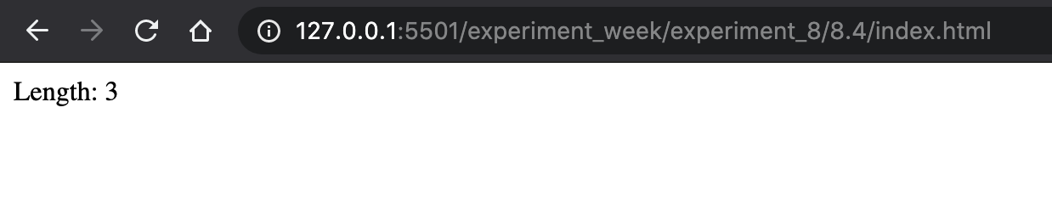

|  |  |  |
| --- | --- | --- |
| **Experiment No-8.5** |  | **Date:** |

**Aim of the Experiment:**

Write a JavaScript program to display the reading status (i.e. display book name, author name and reading status) of the following books.

var library = [

{

author: 'Bill Gates',

title: 'The Road Ahead',

readingStatus: true

},

{

author: 'Steve Jobs',

title: 'Walter Isaacson',

readingStatus: true

},

{

author: 'Suzanne Collins',

title: 'Mockingjay: The Final Book of The Hunger Games',

readingStatus: false

}];

**Source Code**

<!DOCTYPE html>

<html lang="en">

<head>

<meta charset="UTF-8">

<meta name="viewport" content="width=device-width, initial-scale=1.0">

<title>Document</title>

</head>

<body>

<div id="data">

<h2>Library</h2>

</div>

<script>

var library = [

{

author: 'Bill Gates',

title: 'The Road Ahead',

readingStatus: true

},

{

author: 'Steve Jobs',

title: 'Walter Isaacson',

readingStatus: true

},

{

author: 'Suzanne Collins',

title: 'Mockingjay: The Final Book of The Hunger Games',

readingStatus: false

}

];

var data_dom = document.getElementById('data');

library.forEach((data)=>{

data_dom.innerHTML += `

<h4>${data.title}</h4>

<ul>

<li>Author: ${data.author}</li>

<li>Reading Status: ${data.readingStatus}</li>

</ul>

`;

})

</script>

</body>

</html>

**Output**

